**Sprint 4 Report**

**Product Name:** SummarAIze

**Sprint Completion Date:** June 3rd, 2025

**Revision Number:** V1.1

**Revision Date:** June 3rd, 2025

**Actions to Stop Doing:**

* The team should stop underestimating the time needed for technical research tasks, because we have been behind on many topics.
* The team should stop pushing incomplete backend changes to main without full testing, because it wastes a lot of time to fix any errors.

**Actions to Start Doing:**

* The team should start having more pair programming sessions, because it helps solve harder tasks more efficiently.
* The team should start testing all new features on both the backend and frontend before moving tasks to “done”, because it will help clarify to the other team members and prevent any errors.

**Actions to Keep Doing:**

* The team should continue in-person work sessions.
* The team should continue holding regular standups to update our progress.
* The team should continue updating the JIRA board with tasks and their completion status.

**Work Completed / Not Completed:**

* **Work Completed:**
  + **As an educator, I want to be able to create a visual representation so that I can make presentations so that complex concepts are simplified for students.**
    - Task 1: Put visuals in frontend (1 hr)
    - Task 2: Research and add API to generate images (2 hr)
    - Task 3: Research and use Python libraries to create videos (3 hr)
    - Task 4: Add animation over visuals (4 hr) (basic animations added)
    - Task 5: Integrate any visual components with the voiceover (3 hr)
  + **As a student, I need to download videos I previously generated so that I can reference them later.**
    - Task 1: Connect database (1 hr)
    - Task 2: Store videos in database (2 hr)
    - Task 3: Update frontend with download page (2 hr)
    - Task 4: Allow downloading from database through web app (3 hr)
    - Task 5: Deploy the website (5 hr)
* **Work Incomplete:**
  + **As a user, I want to generate a presentation for the contents of the research paper so that I can use it to communicate the information to others effectively.**
    - Task 1: Use Google Slides API (1 hr)
    - Task 2: Parse research paper structure to map to slide content (3 hr)
    - Task 3: Improve presentation themes (3 hr)
  + **As a user, I want to get suggestions for related research papers so that I can explore the topic further.**
    - Task 1: Parse through citations at the end of the paper (1 hr)
    - Task 2: Connect to API to fetch papers based on keywords (3 hrs)
    - Task 3: Update frontend to display suggestions (1 hr)
* **Work Completion Rate: 50%**
  + **User Stories Completed:** **2**
  + **Ideal work hours: 40 hours**
  + **Total Number of Days: 14 days**
  + **Average user stories per day: 0.14/day**
  + **Average work hours per day: approximately 2.5 hour/day**

**Scrum Board:**

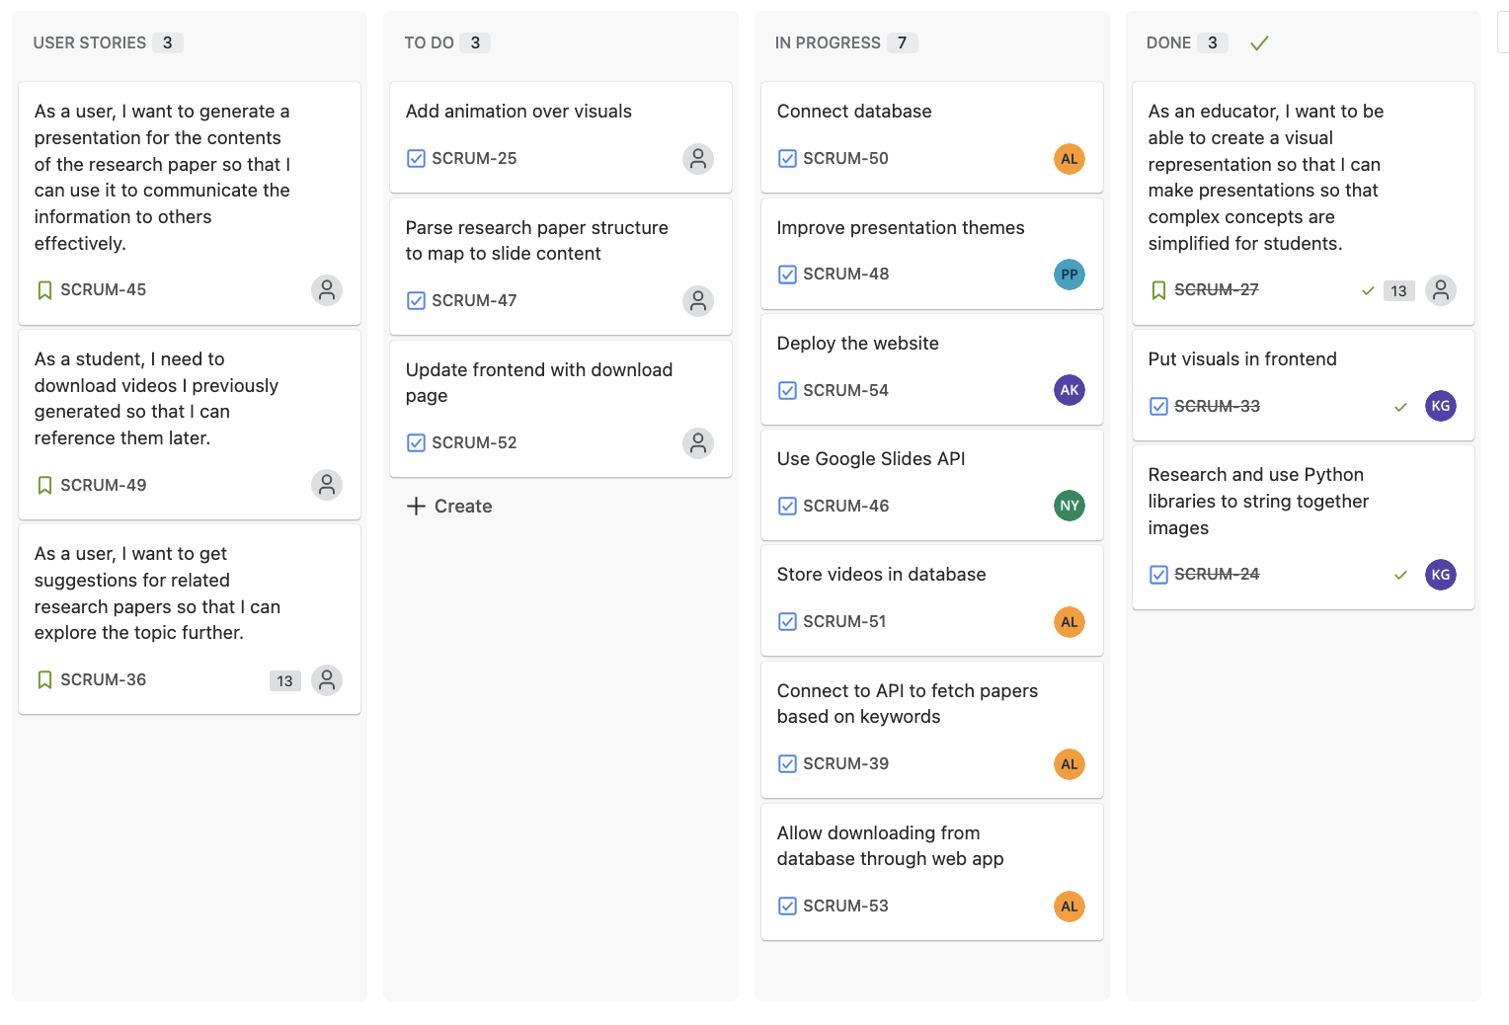

**Burn-up Chart:**

